INDIAN SCHOOL AL WADI AL KABIR
Class: X | Department: Computer Science | Date:07-12-2023
Max Marks:50  Time:2 Hours | ARTIFICIAL INTELLIGENCE (417)  REHEARSAL-1  SET II

General Instructions:
- Please read the instructions carefully.
- This Question Paper consists of 21 questions in two sections: Section A & Section B.
- Section A has Objective type questions whereas Section B contains Subjective type questions.

Out of the given (5 + 16 =) 21 questions, a candidate has to answer (5 + 10 =) 15 questions in the allotted (maximum) time of 2 hours.
- All questions of a particular section must be attempted in the correct order.

SECTION A - OBJECTIVE TYPE QUESTIONS (24 MARKS):
  - This section has 05 questions.
  - Marks allotted are mentioned against each question/part.
  - There is no negative marking.
  - Do as per the instructions given.

SECTION B – SUBJECTIVE TYPE QUESTIONS (26 MARKS):
  - This section has 16 questions.
  - A candidate has to do 10 questions.
  - Do as per the instructions given.
  - Marks allotted are mentioned against each question/part.

SECTION A: OBJECTIVE TYPE QUESTIONS

Q. 1 | Answer any 4 out of the given 6 questions on Employability Skills (1 x 4 = 4 marks)
i. | Which one of the following is an example of Operating System?  (a) Microsoft Word  (b) Microsoft Windows  (c) Microsoft Excel  (d) Microsoft Access | 1
ii. | When you bring the mouse over a file in File Explorer, it will show the details of that file.  This is known as  - Drag and drop  - Double click  - Hover  - Single click | 1
iii. | Assertion(A): A doctor works for a renowned hospital.  Reason(R): The statement given above is an example of wage employment.  - Both A and R are correct and R is the correct explanation of A  - Both A and R are correct but R is NOT the correct explanation of A  - A is correct but R is not correct  - A is not correct but R is correct | 1
iv. | the work is all about identifying and noting how we spent our time, and analysing how to spend our time effectively.  - Organising  - Prioritising  - Controlling  - Tracking | 1
v. | Remya traveled to Sweden from India to pursue her higher education. But she doesn't know how to speak Swedish (language of Sweden). Because of this, she was unable to find a part time job. This is an example of  - Interpersonal barrier  - Physical barrier  - Organisational barrier  - Linguistic barrier | 1
vi. | “Efforts are made to increase the solar power generation so that our electricity needs are met and at the same time we do not pollute the environment or use up natural resources”.  Which SDG can you relate this statement to?  - Life on land  - Clean water and sanitation  - Affordable and clean energy  - Reduced inequalities | 1
Q. 2 | Answer any 5 out of the given 6 questions (1 x 5 = 5 marks)
i. | Assertion (A)– One can be a good singer while the other can be a great athlete.  Reason(R) – Humans possess different types of intelligences but at different levels.  - Both A and R are correct and R is the correct explanation of A  - Both A and R are correct but R is not the correct explanation of A  - A is correct but R is not correct  - A is not correct but R is correct. | 1
ii. | The Indian Government banned a few apps stating – “servers in the hostile nation are receiving and using the acquired data improperly”.  Which terminology suits best for this action?  - AI Ethics  - Data Privacy  - AI Bias  - AI Access | 1
iii. | Statment1: There are four layers in a neural network.  Statement2: The first layer of the neural network is known as the output layer.  - Both Statement1 and Statement2 are correct  - Both Statement1 and Statement2 are incorrect  - Statement1 is correct but Statement2 is incorrect  - Statement2 is correct but Statement1 is incorrect | 1
iv. | Which of the following is correct about the rule-based approach?  (a) We cannot provide enough rules to the machine.  (b) A drawback/feature for this approach is that the learning is static.  (c) Once the rules are fed into the system, it takes into consideration any changes made in the original training dataset.  (d) It can improve itself based on the feedbacks. | 1
v. | is a simple file format that stores data separated by commas?  - jpg  - doc  - csv  - png | 1
vi. | Tom is a student of grade five. He likes to move constantly at his desk. He plays with pencils and taps his fingers, stands up in his place any time he gets a chance. He enjoys playing basketball, and likes to play in the classroom. Which of the following intelligence does he demonstrate?  (a) Linguistic  (b) Logical-Mathematical  (c) Musical  (d) Kinesthetic | 1
Q. 3 | Answer any 5 out of the given 6 questions (1 x 5 = 5 marks)
i. | Read the examples given below-  - Using Chat GPT to write an email  - Face unlock technology of mobile phones using camera  - Turning off lights with IoT device  - Hand sanitizer dispenser having sensor  Choose the options that are not AI  - i and ii  - iii and i  - ii and iv  - i, iii and iv | 1

ii. | When a machine possesses the ability to mimic the following human traits, it is said to have artificial intelligence. Identify the positive traits that an AI machine should possess.  - make decisions ii. bias iii. predict iv. learn and improve on its own  (a) i), and iii) only  (b) i) , iii) and iv) only  (c) ii) and iv) only  (d) i) ,ii), and iv) only | 1
iii. | Which of the following is an application of data science?  - Text summarization  - Target Advertisements  - Face lock in smartphones  - Email filters | 1
iv. | is the process of finding instances of real-world objects in images or videos?  - Instance segmentation  - Object detection  - Classification  - Image segmentation | 1
v. | Which Python package helps in accessing structured data (in tabular form)?  (a) CSV Reader  (b) Spreadsheet Parser  (c) SQL Integrator  (d) Pandas | 1
vi. | F1 Score is the measure of the balance between  - Accuracy and Precision  - Precision and Recall  - Recall and Accuracy  - Recall and Reality | 1
Q. 4 | Answer any 5 out of the given 6 questions (1 x 5 = 5 marks)
i. | How many tokens are there in the sentence given below?  Traffic Jams have become a common part of our lives nowadays. Living in an urban area means you have to face traffic each and every time you get out on the road. Mostly, school students opt for buses to go to school.  (a) 46 (b) 42 (c) 31 (d) 35 | 1
ii. | An AI system uses two broad classes of data namely content data which includes the raw video streams title, description, etc, and user activity data that includes rating a video, favoriting/liking a video, or subscribing to an uploader, and watch time. Based on this, the AI system measures a user’s engagement and happiness. It then starts computing personalized recommendations to the user. Which of the following applications can you relate to this?  (a) self-driving car  (b) Siri  (c) email filters  (d) YouTube | 1
iii. | Rajat has made a model which predicts the performance of Indian Cricket players in upcoming matches. He collected the data of players’ performance with respect to stadium, bowlers, opponent team and health. His model works with good accuracy and precision value. Which of the statement given below is incorrect?  - Data gathered with respect to stadium, bowlers, opponent team and health is known as Testing Data.  - Data given to an AI model to check accuracy and precision is Testing Data.  - Training data and testing data are acquired in the Data Acquisition stage.  (d)Training data is always larger as compared to testing data. | 1
iv. | 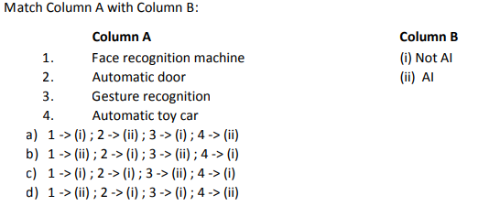 | 1
v. | Which feature of NLP helps in understanding the emotions of the people mentioned with the feedback?  - Virtual Assistants  - Sentiment Analysis  - Text classification  - Automatic Summarization | 1
vi. | What will be the output of the word “studies” if we do the following:  a. Lemmatization  b. Stemming  (a) study , studi  (b) studi , study  (c) study , study  (d) studi , studi | 1
Q. 5 | Answer any 5 out of the given 6 questions (1 x 5 = 5 marks)
i. | Aditi, a student of class XII developed a chatbot that clarifies the doubts of Economics students. She trained the software with lots of data sets catering to all difficulty levels. If any student would type or ask questions related to Economics, the software would give an instant reply. Identify the domain of AI in the given scenario.  - Computer Vision  - Data Science  - Natural Language Processing  - None of these | 1

ii. | Imagine a model telling you that there exists treasure at a point and you keep on digging there but it turns out that it is a false alarm. The prediction result in this case is  (a)True positive  (b)True negative  (c)False positive  (d)False negative | 1
iii. | means a picture element which is the smallest unit of information that makes up a picture.  - Vision  - Pics  - Pixel  - Piskel | 1
iv. | What do you mean by syntax of a language?  - Meaning of a sentence  - Grammatical structure of a sentence  - Semantics of a sentence  - Synonym of a sentence | 1
v. | Which algorithms result in two things, a vocabulary of words and frequency of the words in the corpus?  - Sentence segmentation  - Tokenisation  - Bag of words  (d)Text normalisation | 1
vi. | Assume that you are working at MyFlight which is a major airlines company and that you have noticed that the way passengers board your planes is an inefficient use of time and resources. On an average, the current boarding system wastes about four minutes per boarding. This wastes about 35000 rupees per day across all flights. The boarding protocols make the company less competitive and thus create an unfavorable brand image. Using a modified boarding, passengers can board the plane from the sides rather than from the back to the front. This will eliminate four minutes of waste. Taking this as the problem, choose which of the following would be the ideal problem statement template.  (a) Our passengers have a problem that it takes more time when one has to board the plane. An ideal solution would be to use different airlines.  (b) Our passengers have a problem that the current boarding system wastes time while waiting in the airport. An ideal solution would be to board the plane before the airline crew gets into the plane.  (c) Our airlines have a problem that the current boarding system wastes four minutes of time when passengers aboard the plane. An ideal solution would be to board the plane from the sides rather than from the back to the front.  (d) Our airlines have a problem that it takes more time when passengers have to board the plane. An ideal solution would be to sell the airlines. | 1

SECTION B: SUBJECTIVE TYPE QUESTIONS

Answer any 3 out of the given 5 questions (2 x 3 = 6 marks)

Answer each question in 20 – 30 words.
Q. 6 | List two best practices for effective communication. | 2
Q. 7 | What is the importance of setting goals in life? | 2
Q. 8 | “The Trojan Horse was a wooden horse said to have been used by the Greeks during the Trojan War to enter the city of Troy and win the war”.  What does Trojan horse mean in computer terminology? | 2
Q. 9 | How society is being helped by entrepreneurs through their business? | 2
Q. 10 | Mention any two human activities that lead to environmental degradation. | 2

Answer any 4 out of the given 6 questions in 20 – 30 words each (2 x 4 = 8 marks)
Q. 11 | Sameera is always punctual at school. She has a regular schedule that she follows every day. She plans for study and play time in advance. Enlist the four steps Sameera must have followed for effective time management. | 2
Q. 12 | Sirisha and Divisha want to make a model which will organize the unlabeled input data into groups based on features. Which learning model should they use and why? | 2
Q. 13 | Ajay wants to access data from various sources. Suggest him any two points that he needs to keep in mind while accessing data from any data source. | 2
Q. 14 | Explain the term resolution with an example. | 2
Q. 15 | Identify any two stop words which should not be removed from the given sentence and why?  Get help and support whether you're shopping now or need help with a past purchase. Contact us at abc@pwershel.com or on our website www.pwershel.com | 2
Q. 16 | Draw the confusion matrix for the following data  - the number of true positive = 100  - the number of true negative 47  - the number of false positive = 62  - the number of false negative = 290 | 2

Answer any 3 out of the given 5 questions in 50– 80 words each (4 x 3 = 12 marks)
Q. 17 | Samarth attended a seminar on Artificial Intelligence and has now been asked to write a report on his learnings from the seminar. Being a non-technical person, he understood that the AI enabled machine uses data of different formats in many of the daily based applications but failed to sync it with the right terminologies and express the details. Help Samarth define Artificial Intelligence, list the three domains of AI and the data that is used in these domains. | 4
Q. 18 | Akhil wants to learn how to scope the problem for an AI Project. Explain him the following:  - 4W Problem Canvas  (b)Problem Statement Template | 4
Q. 19 | 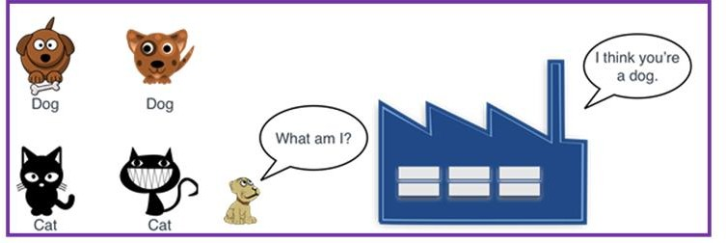  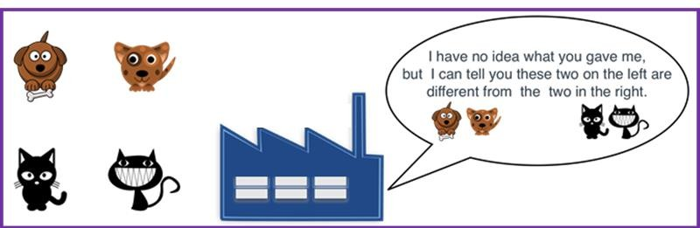  Identify and explain the types of the learning-based approaches in the figures given below.  Figure1  Figure 2 | 4
Q. 20 | We, human beings, can read, write and understand many languages. But computers can understand only machine language. Do you think we might face any challenges if we try to teach computers how to understand and interact in human languages? Explain. | 4
Q. 21 | An AI model made the following sales prediction for a new mobile phone which they have recently launched:  Confusion Matrix Reality  Yes No  Prediction Yes 50 40  No 12 10  - Identify the total number of wrong predictions made by the model.  - Calculate precision, recall and F1 Score. | 4

